Lab 2 Report

Input: Text Data as Input.

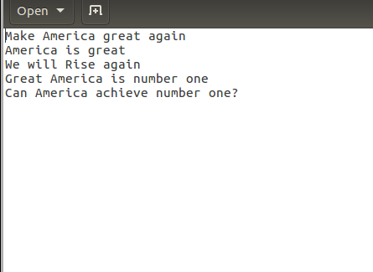

Word Count Output 1:

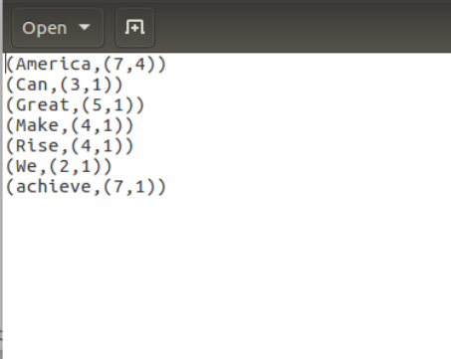

Output 2:

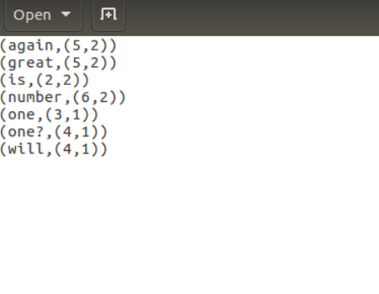

MapReduce Process:

C:\Users\LENOVO\AppData\Local\Microsoft\Windows\INetCacheContent.Word\MapReduce_Process.png

Spark Program Code:





